Enclosed Ultimate Trailers
The Ultimate Trailers® discontinued the enclosed trailer line (models EHT1, EHT2, EHT3 & EHT4) beginning 2019. The reason for this is that the design of the enclosed trailer is very intricate and time consuming that it became impossible to continue charging a reasonable price for them. However, we understand that there are still many enclosed trailers in circulation and if someone purchases a used EHT then they will still need information and/or parts. This article will include the owner’s manual and detail how to acquire replacement parts for the enclosed trailers. The chassis of the enclosed trailers is essentially the same as the open trailers so if you need anything for the deck, the fenders, or anything housed underneath the fenders you can visit: https://www.theultimatetrailers.com/order-parts-accessories .
All EHT trailer orders were custom designed for a customer based on their needs and so some trailers may include items listed below and some may not but all options that were available are included below for informative purposes.
Fiberglass
All fiberglass is made by a company called C.F. Maier in Golden, CO. The fender design has changed slightly a few times over the years so if you order a fender(s) you will want to call us at 1-800-499-1694 to specify the year & month the trailer was manufactured and the side you need (driver’s side or passenger’s side). The enclosure of the trailer is made up of fiberglass pieces, aluminum sheets, and hardware. The fiberglass pieces that make up the enclosure cannot be purchased since when we discontinued the EHT models C.F. Maier got rid of the molds for these pieces. Fiberglass can be repaired at a location near you that manufactures or repairs it, there are also kits/instructions available online to do it yourself if the damage is minimal.
Aluminum Panels
The aluminum panels that cover the center of the enclosure are cut by a company called Alreco Aluminum in Henderson, CO. Panels can be replaced by anyone using the information that follows. All panels are cut from 4 ft. x 10 ft. sheets of 3003 aluminum and comes in white or brushed aluminum. The dimensions for the panels are based on your trailer model and the sizes can be found below:
Model | Panel Size | Number of Panels
EHT1 | 48” x 36” | 5
EHT2 | 48” x 48” | 5
EHT3 | 48” x 60” | 5
EHT4 | 48” x 60” | 6

Alreco does not have a website so call them at 303-287-7210. The sheets also need to be punched to place the bolt holes and the end panels and need to be bent to fit the shape of the trailer.
Hardware
Any hardware needed for the trailer can be found at a local hardware store and all the bolts are 3/8” except the single center bolt that holds the linear actuators to the fiberglass enclosure which is ½”. The hardware set also includes nuts and washers for the bolts as seen to the left.
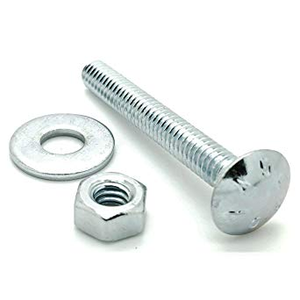
Linear Actuators
The trailer enclosure is opened and closed using two linear actuators on each side of the inside of the trailer and they are made by a company called Venture Manufacturing in Dayton, OH. The original placement of the actuators was in front of the fenders and connected from the deck to the inside wall of the fiberglass portion of the enclosure as shown below:
The actuator model was MA-811038512-46. There were issues experienced with this placement; people reported that there was sway in the enclosure when open and sometimes the actuators were lifting at different speeds. The timing of the actuators can be adjusted on the physical part itself. The issue with sway was addressed by getting longer actuators and placing them behind the fenders from the deck to the inside of the enclosure. The model of these actuators is MA-811138512-46. The actuators are connected to the inside of the fiberglass enclosure with 5 bolts that can be seen from the outside of the enclosure as shown below:
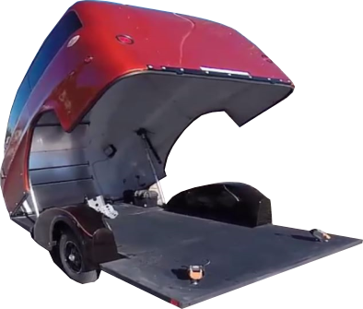
(The outside 4 bolts are 3/8” and the center bolt is ½”). If there is ever an issue with the linear actuators failing to open or close the enclosure one can remove the center bolt, as seen to the right, of the 5 bolts (1/2” bolt) from the outside to release the actuator and then the enclosure can be opened manually. Venture Manufacturing Company does not put part numbers on their website (venturemfgco.com) so you will need to call the number on their website and request the part number through a sales person.
Center Bolt to release actuator (1/2” bolt)
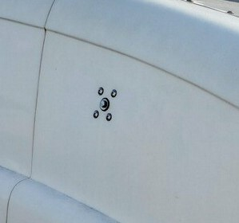
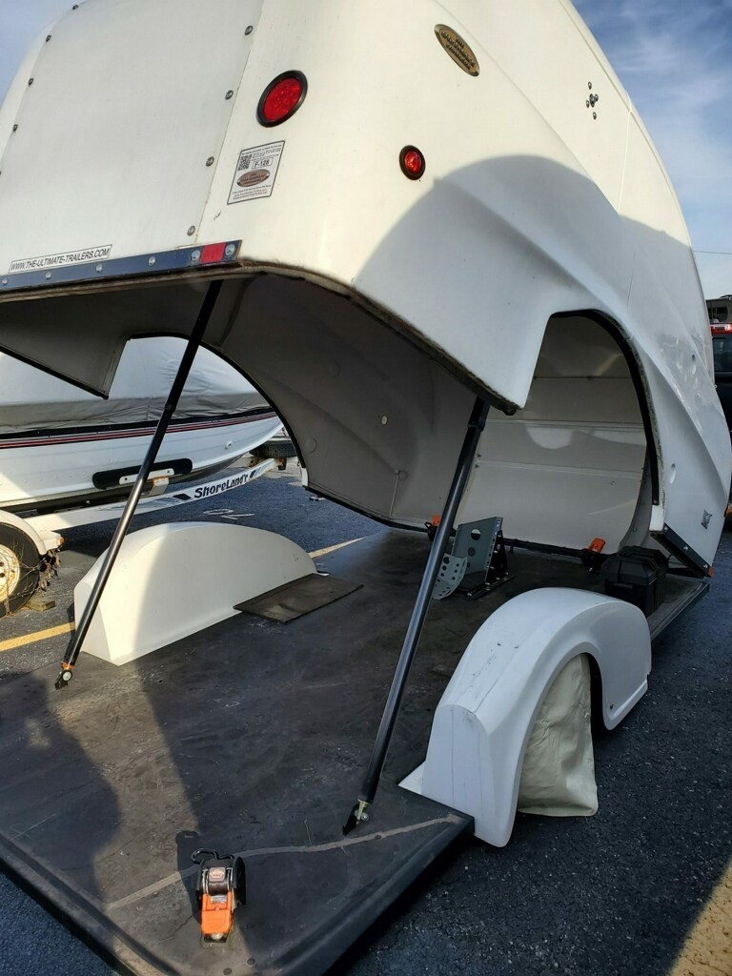
The placement of linear actuators is adjustable based on personal preference. There are many holes drilled on the deck for adjusting wheel chocks/stops and more can be added if needed for placement of items on the deck. Just be careful when drilling holes in the fiberglass enclosure as these pieces cannot be replaced.
Plastic Vent
The plastic vent on the enclosure is found at etrailer.com and it is called “Exterior Half-Moon Trailer Vent for 3" Diameter Hole” or you can order one through us as we have many left. The vents come in black or white.

Internal Wiring
There is wiring inside a conduit on the inside of the enclosure. There is also an EHT Power Control Box Wiring Diagram that is shown to the right. If any wiring becomes an issue the first thing to check is that there is a verified 12 volts coming from whatever power source is being used. Some of the trailers have an on board back-up battery meant to power the trailer in case the tow vehicle becomes unable. A vehicle towing the trailer must have the matching end of the trailer’s wiring harness adapter (usually round 7-pin), 12 volts, and at least a 25-amp fuse in the vehicle’s fuse box. If a function of the trailer does not operate then it is most likely an issue with the power supply (tow vehicle or back-up battery). If it is not the power supply, then there could be an issue with the trailer wiring. All wiring must be done by an expert or things can go very wrong and end up making it almost impossible to diagnose the issue. All wiring can be easily found and replaced at a local hardware store or by your wiring expert. The wiring is housed inside an 8-spot terminal block and then inside an electrical enclosure which can be seen on the left; both of these items can be found at a local hardware store or purchased online.
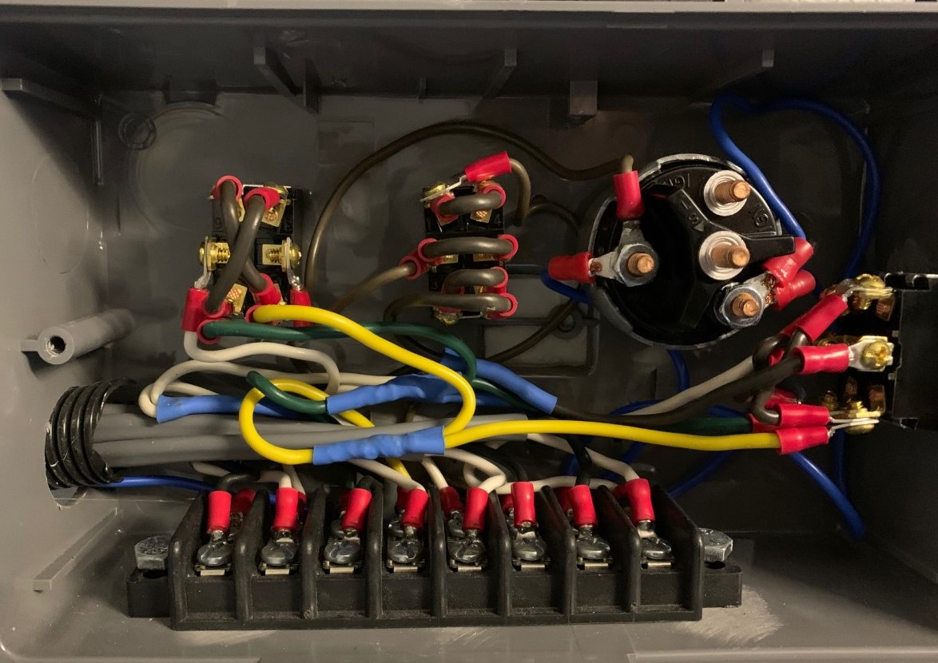
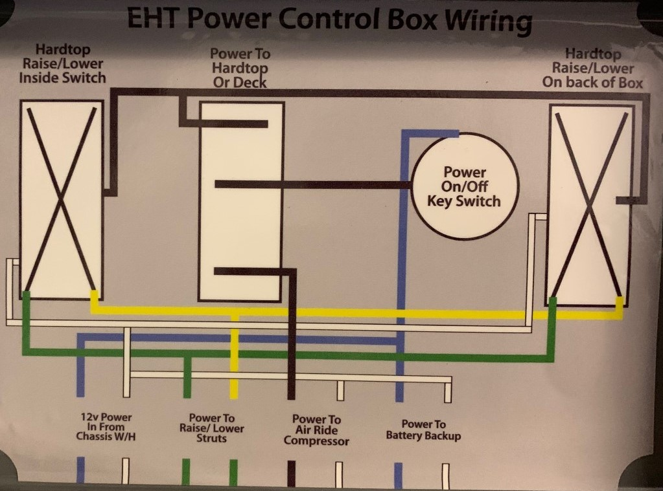
Switches & Control Panels
There are a two 3-position toggle switches on the trailer. One toggles between power from the enclosure to power to the deck as shown to the right. The second toggles between raise or lower the enclosure. The toggle switches are generic and can be found at a hardware store or ordered online. There is also an ignition switch purchased through Del City, the part number is 73455DL and it can be found at: www.delcity.net . A key is required to use the ignition switch and turning the key will allow the lifting and lowering of the enclosure. Seen on the left is the control panel to lift and lower the deck. There is a dump valve with a plastic handle to switch from raise to lower and there is a Schrader valve or auxiliary fill which allows one to fill the air bags in the event there is no power to the air compressor.
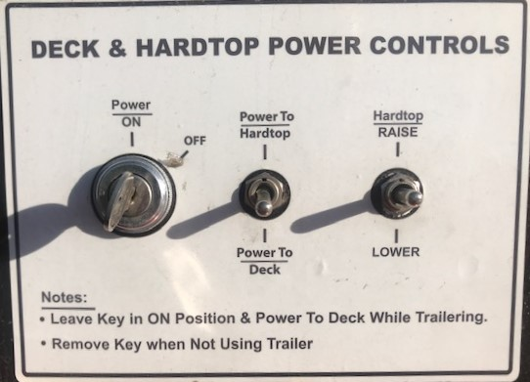
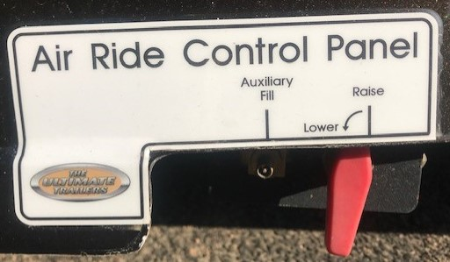
Rear View Camera
Some of the trailer models were wired with a rear view camera on the back side of the trailer. The back-up camera systems came with a small screen that was placed by the driver in the cab of the vehicle and used to see what was behind the trailer while reversing as seen to the left.
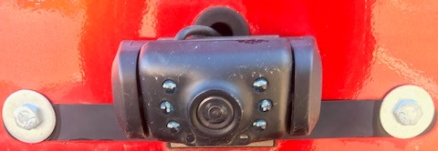
There were many models of camera used on the trailer over the years and any simple back-up camera system will work for the trailer.
Back-Up Battery
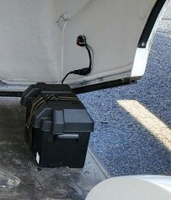
Some of the trailers were set-up with a back-up battery system or battery tender in the event that another power source is unavailable to the trailer. The on board battery is shown to the left.
It is meant to be a secondary power source since it is not limitless. The trailer is meant to be hooked up to a tow vehicle during travel. It is possible to hook the trailer to the back-up battery and then hook the back-up battery to the tow vehicle. Many people use the back-up battery when the trailer is not connected to a vehicle, either for travel or storage. There is an external outlet on the trailer shown to the right that is used to charge the battery tender.
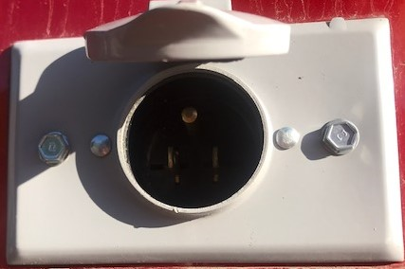

Interior Lighting
Some trailers were purchased with an interior LED lighting system. The system consisted of LED light strips that were placed on the inside of the enclosure and wired in to get power from the trailer’s power supply. This is easily replaced with LED light strips found online or added after-market using Velcro strips.
Wiring Harness
The wiring harness that travels from the trailer, over the tongue, and to the tow vehicle is meant for plugging into the end of vehicle towing the trailer to supply power to the trailer. A new one can be ordered on our website or done by your wiring expert. At least 12 volts are required from the vehicle to operate all the trailer functions and at least a 25-amp fuse is required inside the fuse box of the vehicle. A wiring tester was supplied at the time of trailer purchase to plug into the tow vehicle to ensure there is sufficient power when the trailer is received. It is suggested that one keeps one in the tow vehicle at all times in case there is ever an issue with trailer functions not operating. An example of this tester is shown to the right. A circuit tester like this one can easily be found online.
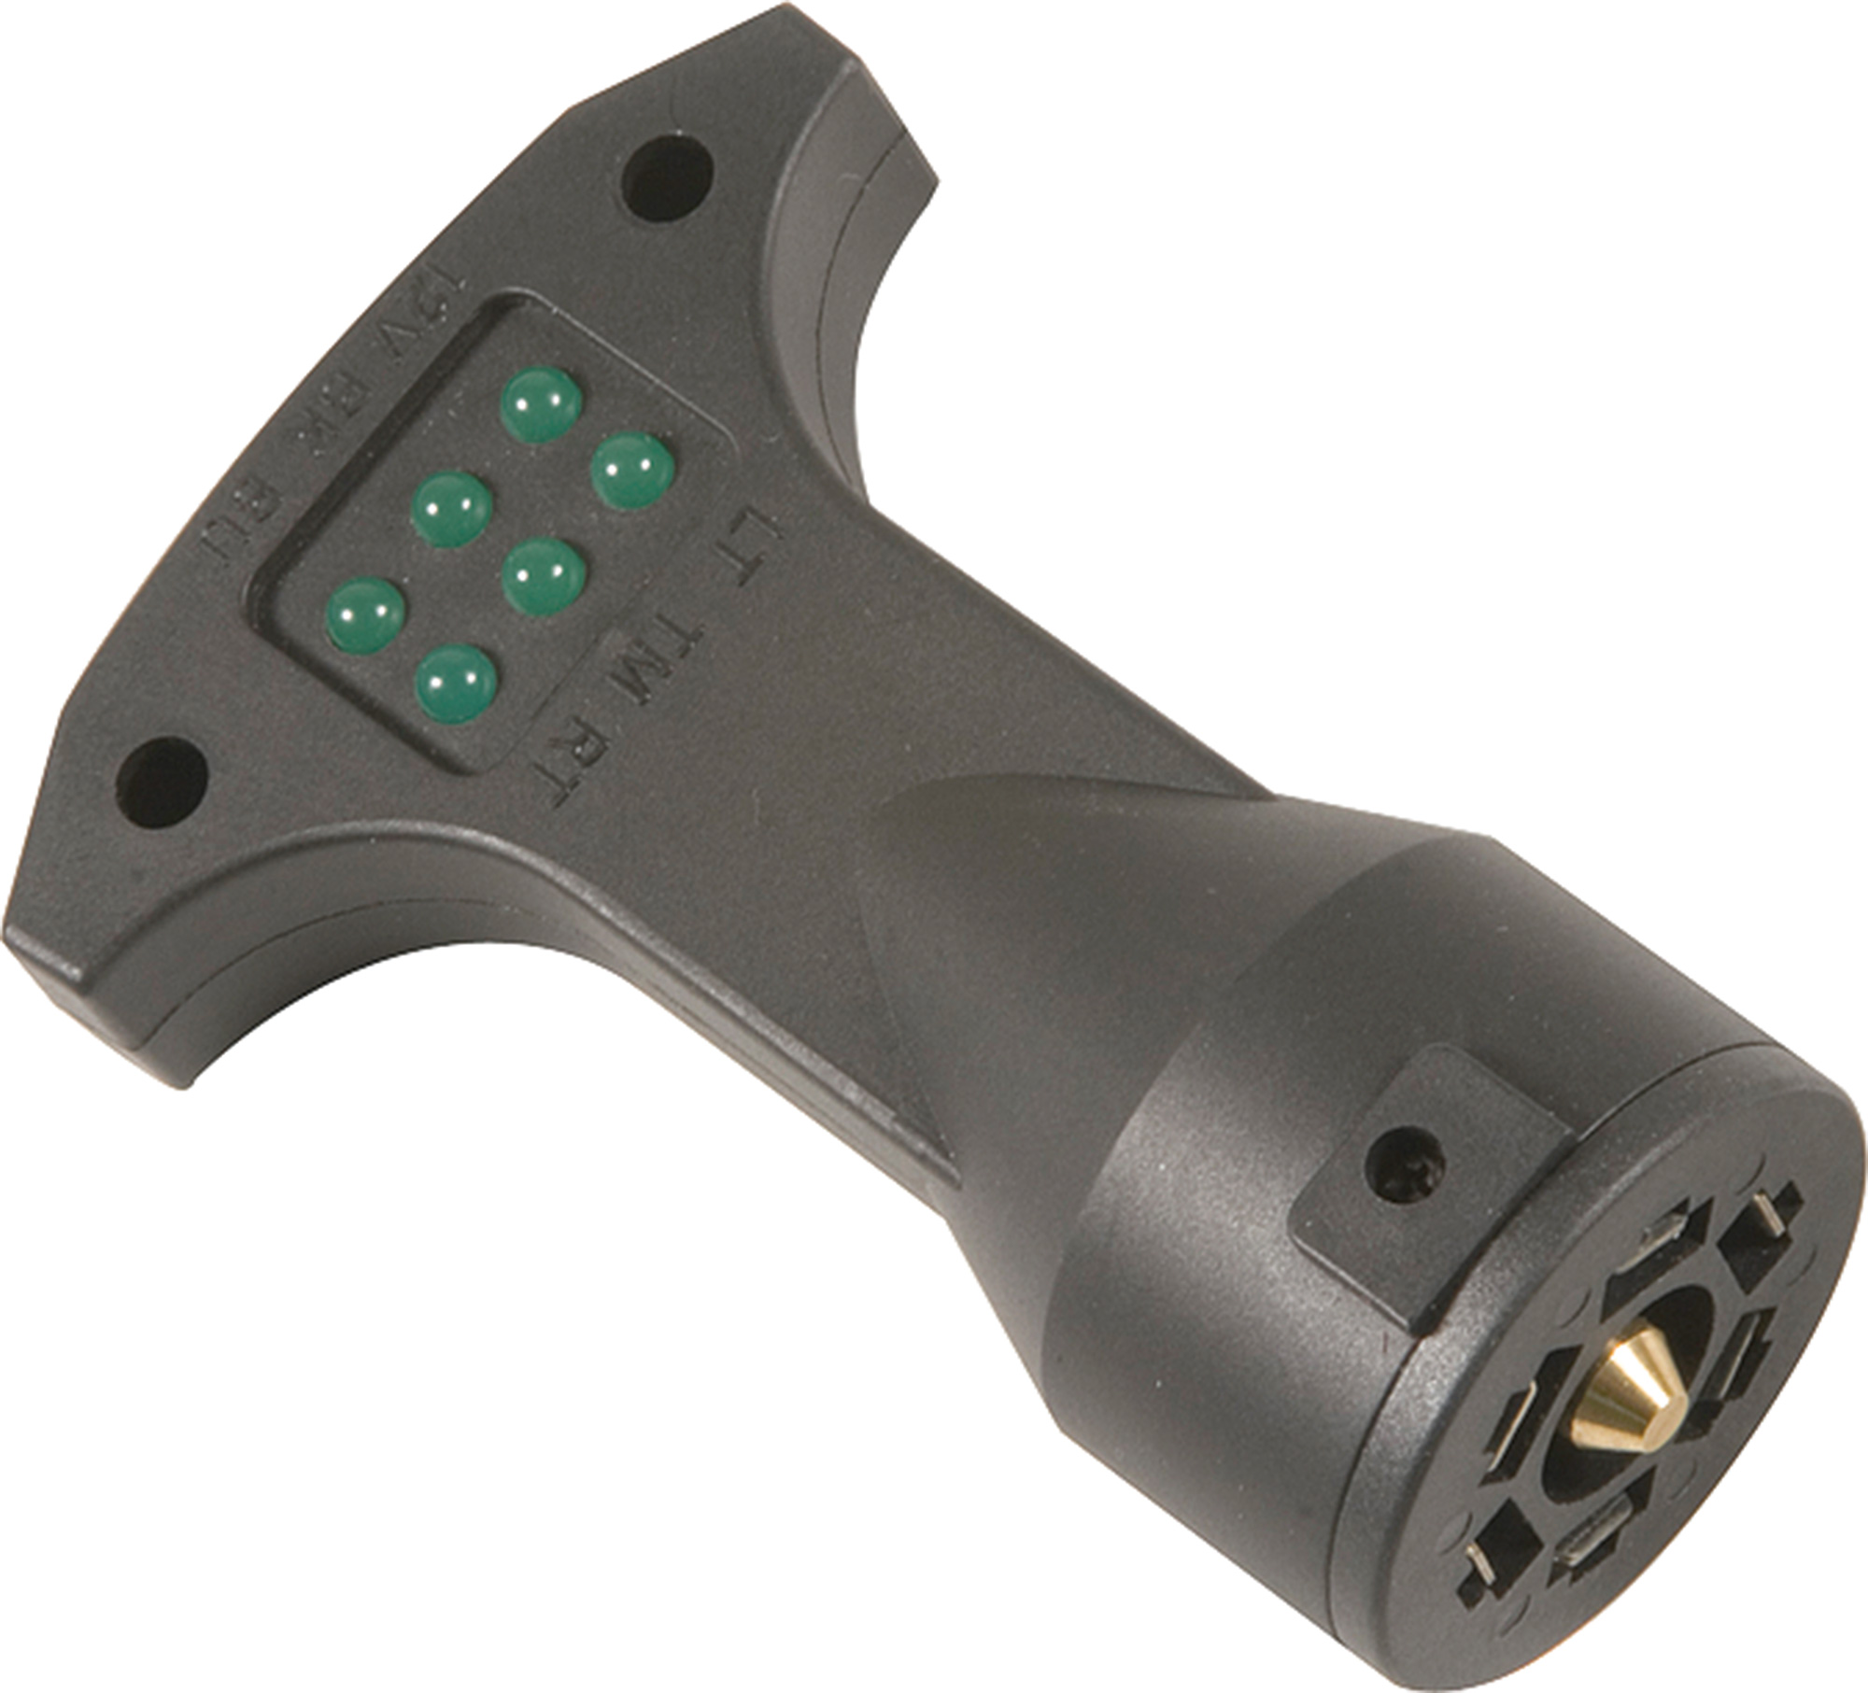

Electric Brakes
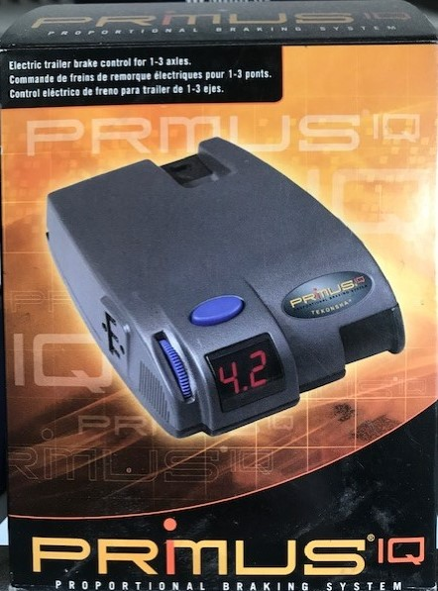
Some trailers were equipped with electric brakes that were connected to the tow vehicle’s brake controller. Some vehicles had built in brake controllers and some required an external brake controller to be hooked up. If a brake controller is not built in to a vehicle, then the brake controller that is recommended is seen to the left. Each side of the trailer has a swing arm and on each swing arm is a spindle. If a trailer is equipped with brakes or has the ability to have brakes installed then behind each spindle, on the end closest to the swing arm, is a square back plate. If this brake plate is present, then brakes are easily installed; if there is no square back plate present then one would have to be welded on to make brake installation possible. The back plate on the spindle is shown to the right.
Back Plate on Spindle for Brakes
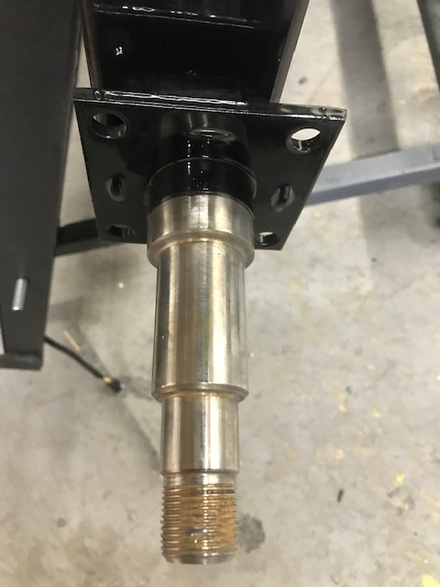
General Towing Information
The trailer tongue comes with a built-in jack to lift it onto the vehicle’s tow ball and lower it down for securing the trailer to the vehicle for travel. A new jack can be purchased through us. The trailer requires a 2” ball about 12” to 14” off the ground. It is suggested that a drop-down hitch is kept in the tow vehicle in the event that the trailer deck is stuck in the lowered position. If the air compressor is unable to function or if there is damage to an airbag and it is unable to hold air, then the trailer can still be towed using a drop down hitch. When the drop down hitch is used then it will lower the front end of the trailer which will in turn lift the back end far enough off the ground for travel.
A trailer with one or two wheel stops in the front is built for a power-sport toy that has one or two front wheels, respectively. A trailer with one or two wheel chocks is built for one or two motorcycles, respectively. The trailer deck is drilled with a multitude of bolt holes so any trailer can have the wheel stops or wheel chocks moved, removed, or swapped to be used to tow something different. Ratchet straps, the brackets that hold them to the deck, and the soft straps can be moved and more can be purchased from our website. Replacement lights can also be purchased through our website. Some trailers were equipped with LED lights but if you need to replace a non-LED light then you can call and request that part through our customer service representative.

